Covid-19 Safety Precautions at Oasis United Church
Welcome! Below are the safety precautions we have in place for in-person services at Oasis United Church.
Masks
Masks are required for attending worship, and high quality masks are strongly encouraged. We have a supply of N95 masks — ask a volunteer greeter at the door if you would like one and do not have your own.
See the graphic below to learn how N95s compare to other types of masks in preventing the spread of COVID-19. If you would like to purchase N95 masks you can find them at canadastrongmasks.ca or vitacore.ca, and London Drugs often has them in stock. N95 masks last for 200 hours as long as they are clean and in good condition.
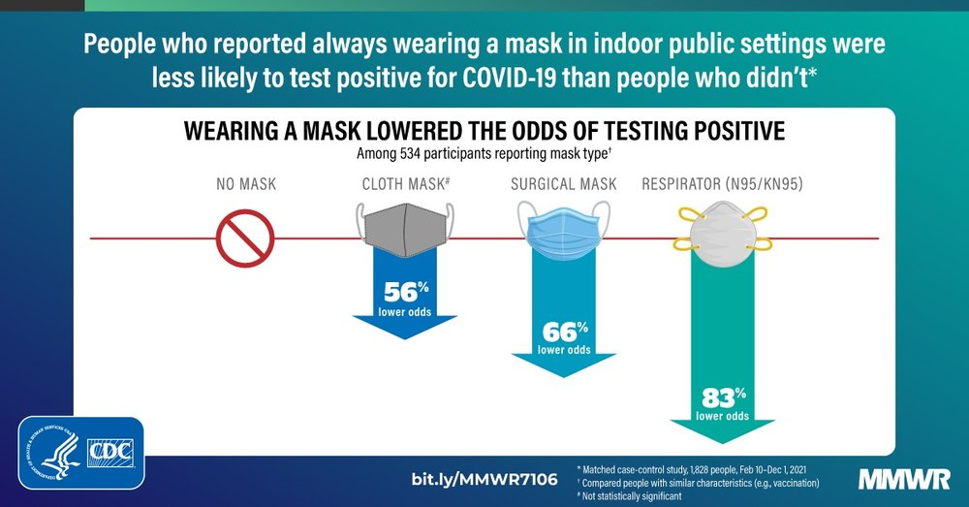

Air Circulation
To provide as much air circulation as possible, doors and windows will be kept open during the service, so you may want to bring an extra layer. Air filtration through Corsi-Rosenthal boxes (https://en.wikipedia.org/wiki/Corsi–Rosenthal_Box) will also be in place.
Eating/Drinking
As we do not wish to encourage people to remove their masks indoors, any eating or drinking needs to be done outside. We also will continue to offer communion services over Zoom on the first Sunday of every month in the evening.
Finally, if you are experiencing symptoms, please stay home to limit the spread.
Thank you for your understanding and patience as we navigate offering integrated services and we prioritize safety for all those attending in person.

